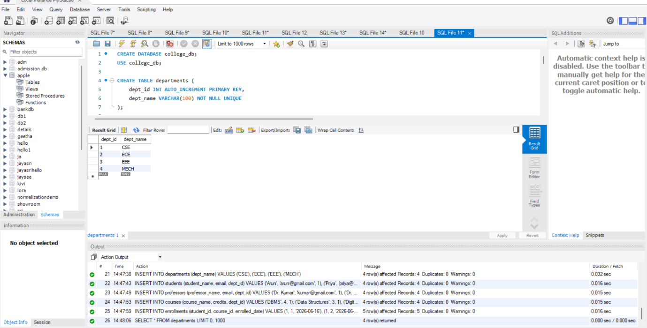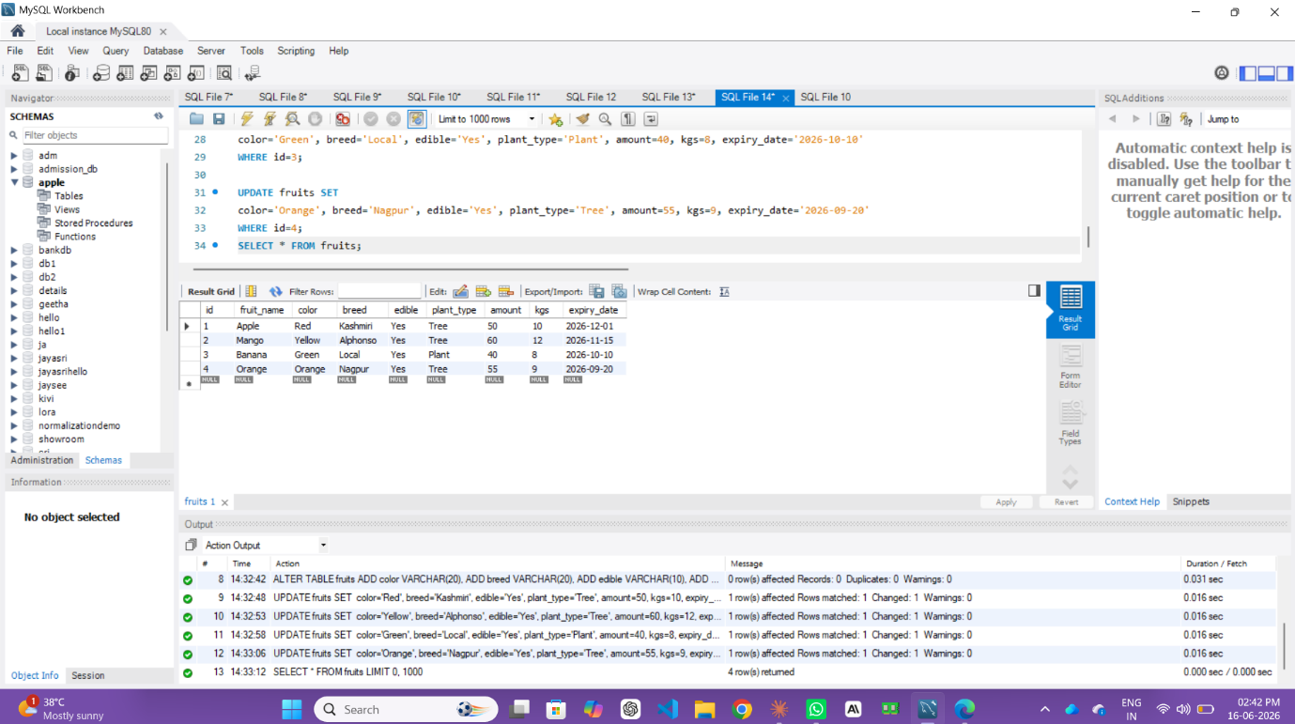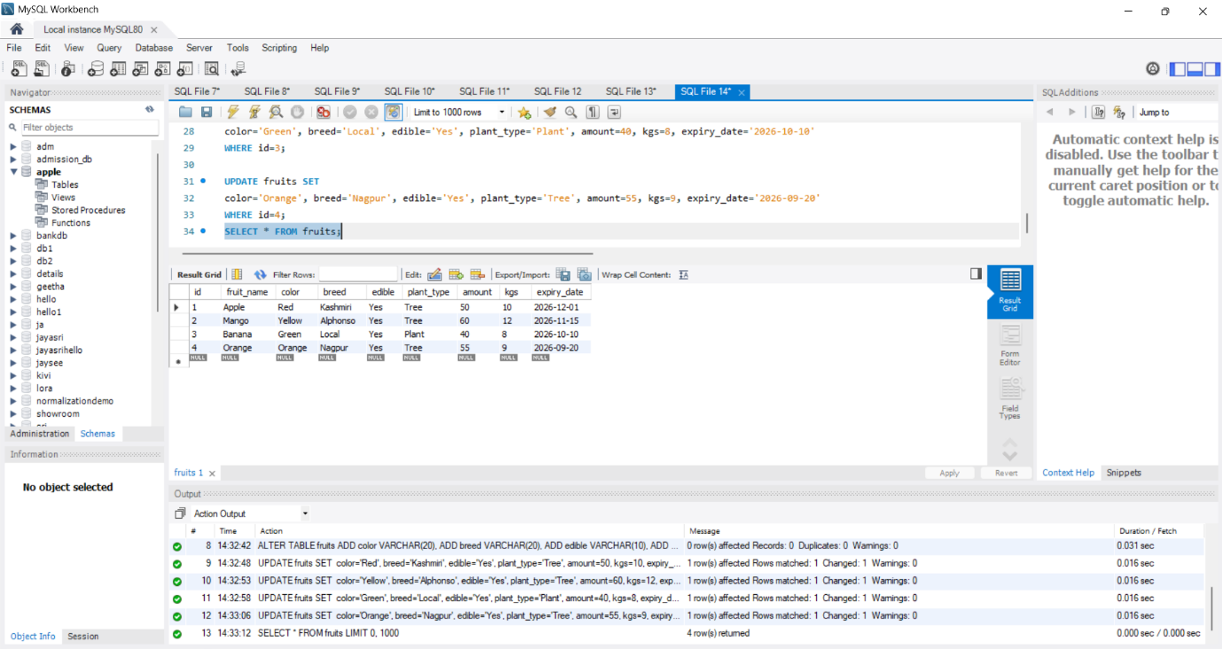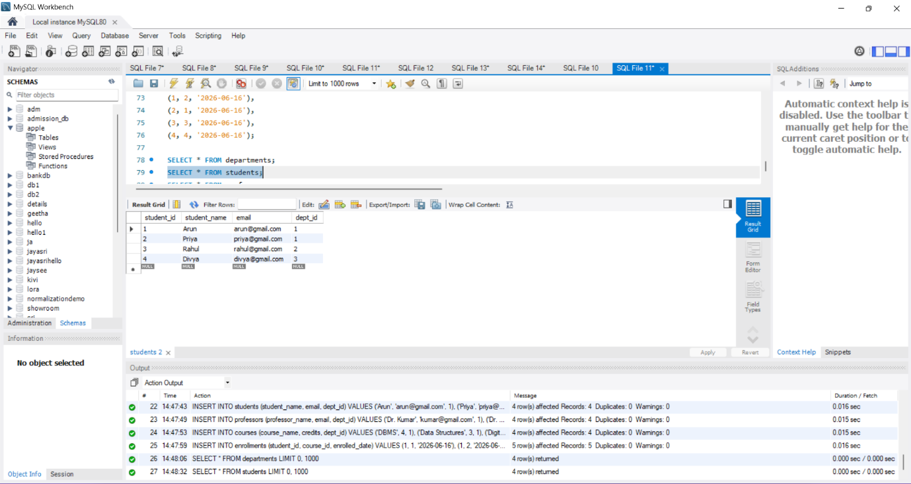
TASK 2: NORMALISATION VERIFICATION -- ============================================ -- ---------------------------- -- 1NF (First Normal Form) -- ---------------------------- -- Rule: Every column must hold atomic (indivisible) values. -- No repeating groups or multi-valued fields. -- CHECK: All tables in college_db satisfy 1NF because: -- - Each column holds a single value (e.g., student_name is one name, not "Ram, Sam") -- - Each row is uniquely identified by a PRIMARY KEY -- HYPOTHETICAL VIOLATION: -- If we stored phone numbers as "9876543210, 9123456789" in one column → violates 1NF -- Fix: Create a separate student_phones table with one phone per row. -- ---------------------------- -- 2NF (Second Normal Form) -- ---------------------------- -- Rule: Must be in 1NF + every non-key column must depend on the WHOLE primary key. -- (Partial dependency not allowed — matters only when PK is composite) -- CHECK: enrollments table -- Composite candidate key: (student_id, course_id) -- Columns: enrollment_id, enrolled_date -- - enrolled_date depends on BOTH student_id + course_id (when did THIS student join THIS course) ✓ -- HYPOTHETICAL VIOLATION: -- If enrollments had a column "student_name" → it depends only on student_id, not course_id -- That's a partial dependency → violates 2NF -- Fix: student_name belongs in students table (already done ✓) -- ---------------------------- -- 3NF (Third Normal Form) -- ---------------------------- -- Rule: Must be in 2NF + no transitive dependencies. -- (Non-key column should NOT depend on another non-key column) -- CHECK: students table -- PK: student_id -- Columns: student_name, email, dept_id ✓ -- HYPOTHETICAL VIOLATION: -- If students table had dept_name column: -- student_id → dept_id → dept_name ← transitive dependency! -- dept_name depends on dept_id, not directly on student_id → violates 3NF -- Fix: Store dept_name only in departments table, reference via dept_id FK (already done ✓) -- CONCLUSION: -- All 5 tables satisfy 1NF, 2NF, and 3NF. -- No partial or transitive dependencies exist in the current schema.

